
Baby’s Room
Leader: God gives us the precious gift of life. May we always reverence every life, and care for those who need our care the most. May God watch over and keep our baby safe from all harm. We pray to the Lord.
All: Lord hear our prayer.

Boy’s Room
Leader: Jesus was a boy. He understands and knows each of us better than we know ourselves. May He guide us always and help us to grow. May He make us humble in good times, and may He give us strength and humility in bad times. In everything may we serve Him as best we can. We pray to the Lord.
All: Lord hear our prayer.

Girl’s Room
Leader: The greatest human person who ever lived was a woman. Before she was a woman, she was a girl. Mary did not always know what God had in store for her, but she followed in faith. May God bless our femininity, our girlhood, our young womanhood. May He guide us always so that our lives may give Him glory. We pray to the Lord.
All: Lord hear our prayer.

Garage
Leader: From here we go, back here we come. May God protect us on our journeys and bring us safely back home. May he give us wisdom and skill and patience in driving so that we shall always respect our lives and the lives of others. We pray to the Lord
All: Lord hear our prayer.

Bathrooms, Closets, Utility rooms
Leader: So many rooms are necessary for the good functioning of the home. May each room always show forth our respect for each other. May we work together to keep them clean so that the entire family may always enjoy this home in its fullness. We pray to the Lord.
All: Lord hear our prayer.

Family Room /Living Room
Leader: In this room we watch television, we read, we talk, we entertain friends, we relax, we hear music. May everything that we do in this room be done for the glory of God. May all that we hear, all that we see, be worthy of this. We pray to the Lord.
All: Lord hear our prayer.
(The family then joins hands and prays together the Lord’s Prayer.)

The Blessing of Homes on Epiphany




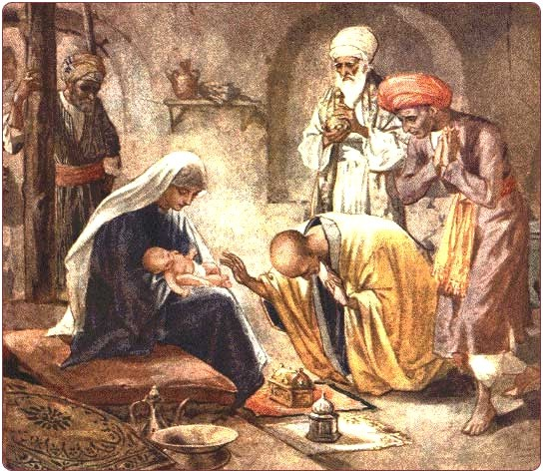
2026

Blessing of Homes on Epiphany
In the Universal Church Epiphany is a Holy Day of Obligation, observed January 6, “The Twelfth Day of Christmas”, or the Sunday between January 2 and January 8.
The blessing of homes on Epiphany is a very old Catholic custom. When the Wise men or Magi became an important focus in the celebration of the Epiphany, the blessing of homes was a natural conclusion: the Wise Men came to bring gifts to honor the King of Kings, but when they entered the home at Bethlehem, they were blessed by Him whom they came to bless! Since the high Middle Ages, the names Caspar, Melchior and Balthazar have been given to the Magi, and they have been honoured as saints. There is a magnificent reliquary of their alleged remains behind the high altar of the Cathedral of Cologne, Germany. The actual facts and history of the Magi are not nearly so important as the celebration. We too, are always blessed by those whom we go to bless. To give is to receive.
To dedicate our homes to Christ is to gain untold blessings from Him who manifested Himself in glory to the world on Epiphany. In the golden age of Liturgy, two other mysteries were also celebrated on Epiphany: the Baptism of Jesus by John the Baptist, and the Wedding Feast at Cana. Each of these mysteries gives meaning to the blessing of homes.
By sharing in the Wedding Feast of Cana, Jesus blessed married life and family life in the home. By His baptism, Jesus was consecrated as the Suffering Servant of the Lord. He began His mission to reconcile and to save. We begin our mission as Christians from our family life in the home.
(The family gathers at the front door.)

Leader:
Peace be to this home and to all who live here! Blessed be God the Father and the Son and the Holy Spirit who live within us!
All: Now and forever!

Leader:
In the third Mass of Christmas Day, we heard the opening words of the Gospel according to John: “In the beginning was the Word and the Word was with God, and the Word was God! He was in the beginning with God. All things came to be through Him, and without Him, nothing came to be. And the Word was made flesh and made His dwelling among us, and we saw His glory, glory as the only begotten Son of the Father”.
When the translation says that He “made His dwelling among us”, the real words are “He pitched His tent among us”. It teaches us the very down to earth and personal presence of Christ with us. He is here in this home. May He always be in our hearts. Today, in signs and in symbols we renew our realization of the presence of the Lord in our home.

(The leader marks over the door the following: 20+C+M+B+26 which represents the initials of the traditional names of the Magi and also the abbreviation of the Latin “Christus Mansionem Benedicat”, which means “May Christ bless the house” and the year.)

Leader:
We have written the number of this new year together with the initials of the Magi - Caspar, Melchior and Balthazar. May God always send His angels to dwell in this home. May He keep us always in His peace and love. May we provide welcome to strangers and to those in need. May He bless our coming and our going so that everything that comes to this home or goes forth from this home may always be guided by the light of faith, hope and love. We ask all these things through Christ our Lord.
All: Amen.
(The family then goes from room to room sprinkling each room with holy water. If the room is more significant to one member of the family, that member of the family may sprinkle that room, and lead the petition. As the family goes from room to room, the following or other petitions more suited to the family may be used . Petitions below which are not relevant should be omitted. After sprinkling all the rooms the family gathers back in the living or family room.)

Dining Room

Leader:
Bless us Lord, when we eat our meals together. May the food we take here make us long for the Bread of Life and may our meals here be a pledge and foretaste of the banquet you prepare for us in heaven. We pray to the lord.
All: Lord, hear our prayer.

Kitchen

Leader:
Families must work together and co-operate in preparation of meals and in cleaning up afterward. May God bless the work of each of us, and make us appreciate the work that each contributes for the good of this family.
We pray to the Lord.
All: Lord, hear our prayer.

Parents’ Bedroom

Leader:
Fathers and Mother are given the awesome responsibility of guiding their children in this world to the world to come. May the Father and Mother of this house always be guided by the Holy Family.
May God give them wisdom and strength to guide this family always in truth and in love. We pray to the Lord.

All: Lord hear our prayer.

